**Steps to log in for Join VC Meeting**

Step 1.Click on the link shared on your email-id.

**URL:** https://bharatvc.nic.in/join/

**Meeting ID:** -

**Password:** -

Step 2. Enter the password sent on the email only.

Step 3. Click on - Join from your browser

*[Instead of logging through App****kindly prefer login using Google Chrome Browser****]*

*.  (Snapshot below highlighted in yellow)*

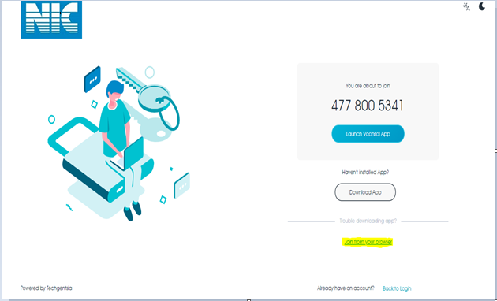

***NOTE****:- It is preferred to use a secure connection through WIFI or broadband connection only. Usage of Data cards and Mobile data should be avoided.*